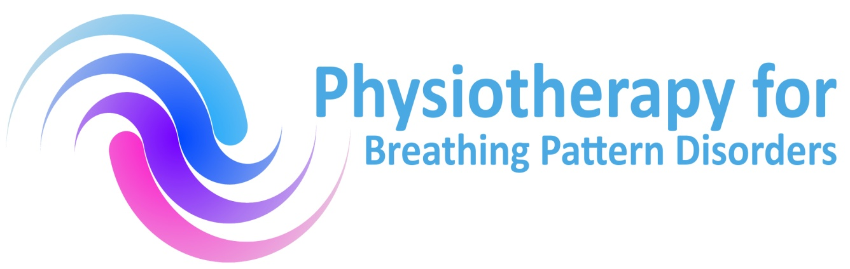
Physiotherapy for Breathing Pattern Disorders
CPD Day: Saturday November 16th2019
Venue: Atrium Health, Coventry
Unit 1, Watch Close, Coventry, CV13LN

Provisional Programme
9.30-10am – Registration and networking
10-10.30am – BPD Group Update
10.30-11am – Classification Update/Discussion
11.15-11.30am - Refreshment Break
11.30am -12.30pm – Outcome measures & Assessment Proforma agreement
12.30pm-1.15pm – Lunch
1.15pm – 2.45pm – BPD and chronic Lung disease
2.45pm-3pm – Refreshment Break
3-4pm - Case Studies
4-4.30pm - Q & A Problem patients
Venue details can be found:
www.atrium-health.co.uk

