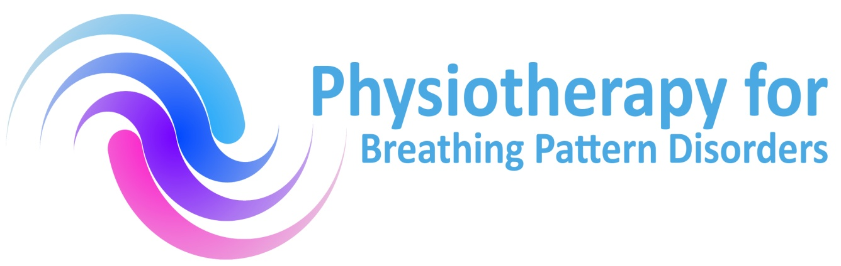

Application form for Annual CPD study day

Physiotherapy for Breathing Pattern Disorders

Date: Saturday 16th November 2019

Venue: Atrium, Centre for Exercise and Health, Coventry

Name:

Work Address:

Post code:

Contact number
Email address
Position
Speciality
- PAYMENTS BY CHEQUE payable to Physiotherapy for bpd
- £50 (sandwich lunch and refreshments included)
- Payment by Internet bank transfer: Barclays, Physiotherapy for bpd sort code: 20.17.35 a/c number:- 30732362
Without payment a place will not be secured. Cheques are non-refundable after the closing date. Closing date: November 9th
Please return application forms and cheque by post to Gill Watkin, PfH Committee 12 Loughborough Road, Hoton, Loughborough, Leicestershire LE12 5SF
Or send application form to me via email below if you use internet bank transfer option. If you have any enquiries please email gillwatkin@ outlook.com or tel. 01509 880982
Thank you.

