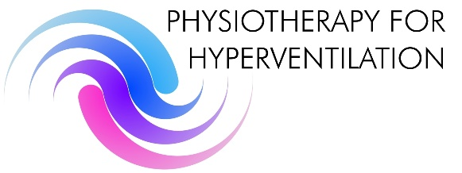

Application form for Annual study day

Physiotherapy for Hyperventilation

Date: Saturday 25th November 2017

Venue: King Richard III Visitor Centre, 4A St.Martin’s, Leicester LE1 5DB

Name:

Address:

Post code:

Contact number
Fax number
Email address
Position
Speciality
- PAYMENTS BY CHEQUE payable to ‘Physiotherapy for hyperventilation’
- £100 (lunch and refreshments included)
- Payment by Internet bank transfer: Barclays, Physiotherapy for Hyperventilation sort code: 20.17.35 a/c number:- 30732362
Without payment a place will not be secured. Cheques are non-refundable after the closing date. Closing date: October 31st 2017
Please return application forms and cheque by post to Gill Watkin, PfH Committee 12 Loughborough Road, Hoton, Loughborough, Leicestershire LE12 5SF
Or send application form to me via email below if you use internet bank transfer option. If you have any enquiries please email gillwatkin@outlook.com or tel. 01509 880982.
Thank you.

